1. Implement and study the performance of CDMA on NS2/NS3 (Using stack called Call net) or equivalent environment.

set stop 100 ;

set type cdma ;

set minth 30

set maxth 0

set adaptive 1 ;

set flows 0 ;

set window 30 ;

set opt(wrap) 100 ;

set opt(srcTrace) is ;

set opt(dstTrace) bs2 ;

set bwDL(cdma) 384000

set propDL(cdma) .150

set ns [new Simulator]

set tf [open out.tr w]

$ns trace-all $tf

set nodes(is) [$ns node]

set nodes(ms) [$ns node]

set nodes(bs1) [$ns node]

set nodes(bs2) [$ns node]

set nodes(lp) [$ns node]

proc cell_topo { } {

global ns nodes

$ns duplex-link $nodes(lp) $nodes(bs1) 3Mbps 10ms DropTail

$ns duplex-link $nodes(bs1) $nodes(ms) 1 1 RED

$ns duplex-link $nodes(ms) $nodes(bs2) 1 1 RED

$ns duplex-link $nodes(bs2) $nodes(is) 3Mbps 50ms DropTail

puts " cdma Cell Topology"

}

proc set_link_para {t} {

global ns nodes bwDL propDL

$ns bandwidth $nodes(bs1) $nodes(ms) $bwDL($t) duplex

$ns bandwidth $nodes(bs2) $nodes(ms) $bwDL($t) duplex

$ns delay $nodes(bs1) $nodes(ms) $propDL($t) duplex

$ns delay $nodes(bs2) $nodes(ms) $propDL($t) duplex

$ns queue-limit $nodes(bs1) $nodes(ms) 20

$ns queue-limit $nodes(bs2) $nodes(ms) 20

}

Queue/RED set adaptive_ $adaptive

Queue/RED set thresh_ $minth

Queue/RED set maxthresh_ $maxth

Agent/TCP set window_ $window

source web.tcl

switch $type {

cdma {cell_topo}

}

set_link_para $type

$ns insert-delayer $nodes(ms) $nodes(bs1) [new Delayer]

$ns insert-delayer $nodes(ms) $nodes(bs2) [new Delayer]

if {$flows == 0} {

set tcp1 [$ns create-connection TCP/Sack1 $nodes(is) TCPSink/Sack1 $nodes(lp) 0]

set ftp1 [[set tcp1] attach-app FTP]

$ns at 0.8 "[set ftp1] start"

}

proc stop { } {

global nodes opt tf

set wrap $opt(wrap)

set sid [$nodes($opt(srcTrace)) id]

set did [$nodes($opt(dstTrace)) id]

set a "out.tr"

set GETRC "../../../bin/getrc"

set RAW2XG "../../../bin/raw2xg"

exec $GETRC -s $sid -d $did -f 0 out.tr | \

$RAW2XG -s 0.01 -m $wrap -r > plot.xgr

exec $GETRC -s $did -d $sid -f 0 out.tr | \

$RAW2XG -a -s 0.01 -m $wrap >> plot.xgr

exec xgraph -x time -y packets plot.xgr &

exit 0

}

$ns at $stop "stop"

$ns run

Output:

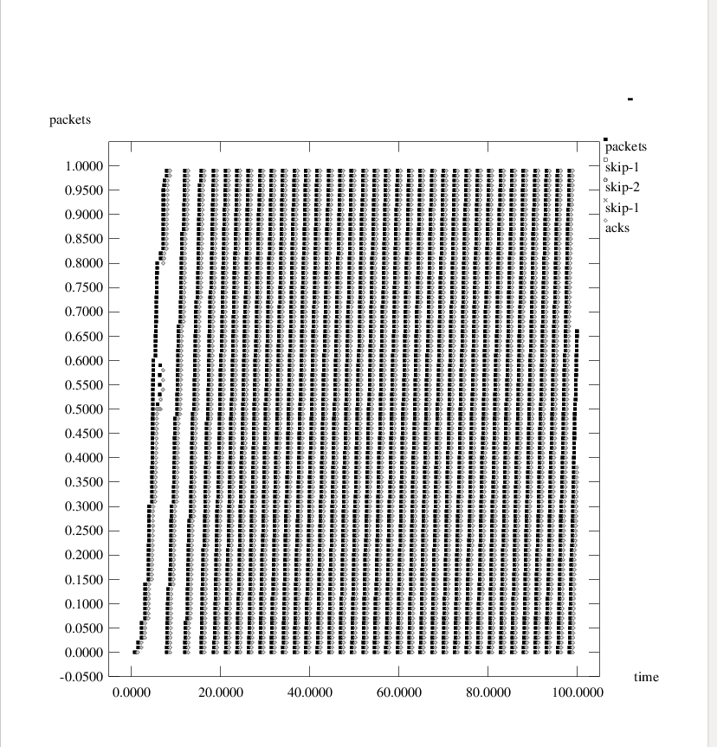

CDMA Trace File:

